**Monash ADR overall Statement**

**Place and Parametricism explores the relationship between theories of place and parametric practices in architectural, interior and landscape design education and research. This ARC project asks 'can place be adequately encompassed by the qualitative methods of digital and parametric design?' and exposes the opportunities and limitations of both place and parametric knowledge and methods through the agency of the design studio**

**Studio 2 Invisible Place Exhibition content**

All student work used in the mp4

<https://liveswinburneeduau-my.sharepoint.com/personal/jrutten_swin_edu_au/_layouts/15/onedrive.aspx?csf=1&e=zZLN1b&cid=1d52e283%2Da3ea%2D401a%2Daa25%2D22733addaaa9&FolderCTID=0x012000DD582A0B221CA64D810A63DE852F41E8&id=%2Fpersonal%2Fjrutten%5Fswin%5Fedu%5Fau%2FDocuments%2FARC%20Place%20and%20Parametricism%2F02%20Exhibition%2FADR%20Monash%20Exhibition%202019%2FStudio%202%20Exhibition%20content>

mp4 exhibition video for screenshots

<https://liveswinburneeduau-my.sharepoint.com/personal/jrutten_swin_edu_au/_layouts/15/onedrive.aspx?csf=1&e=zZLN1b&cid=1d52e283%2Da3ea%2D401a%2Daa25%2D22733addaaa9&FolderCTID=0x012000DD582A0B221CA64D810A63DE852F41E8&id=%2Fpersonal%2Fjrutten%5Fswin%5Fedu%5Fau%2FDocuments%2FARC%20Place%20and%20Parametricism%2F02%20Exhibition%2FADR%20Monash%20Exhibition%202019%2FStudio%202%20Exhibition%20content%2Fgormenghast%5F2%2Emp4&parent=%2Fpersonal%2Fjrutten%5Fswin%5Fedu%5Fau%2FDocuments%2FARC%20Place%20and%20Parametricism%2F02%20Exhibition%2FADR%20Monash%20Exhibition%202019%2FStudio%202%20Exhibition%20content>

Studio 2 Research Statement

**Real, Material and Ethereal original abstract proposal**

**Design research theory and education: Invisible place: Bounded Interiors**

*Invisible place: Bounded Interiors* is an exhibition arising from ongoing research inquiry into the nature of relationships between theories of place and parametric practices in architectural and interior design education. The basis for this research resides in the Place and Parametricism ARC project that asks; ‘can place be adequately encompassed by the quantitative methods of digital and parametric design?’ The project’s design research laboratory projects seek to expose the limitations of both place and parametric knowledge and methods through the agency of the Masters design studio. The application of literary text, material explorations and analogue and digital modelling to real world places and actions drives the inquiry through an initial sequence of three experimental investigations into digital/analogue representations around imaginative, performative and material/virtual interior place works.

In the ultimate project, Ecology of Place Interiority, experiments pose re-homing the un-homed in a 19th century education building deemed no longer fit for useful occupation, Domain House in Hobart. The studio exercises inform the parametically-derived re-occupation of the extant interior with the intent to model new, temporary living environments in existing spaces to facilitate making home in this city, currently experiencing a housing crisis.

Based upon initial readings into the imaginary nature of place occupation in the *Gormenghast* trilogy (Peake, 1946,1950) and further informed by theoretical texts and practice examples into place (Malpas, 1999) and parametics (Burry, 2011), the *Invisible place: Bounded Interiors* exhibition also contributes to the exposition of critical and speculative design outcomes as envisaged in the Place and Parameticism project.

The display will consist of a series of graphic, animated and three-dimensionally modelled projects drawn from the design research laboratory program (2019) into the nature of interiority, transient homing, reuse and the implicit relational aesthetics and practices afforded by parametric approaches to place.

References:

Burry, M.C. (2011), Scripting Cultures: Architectural design and programming, West Sussex: John Wiley and Sons

Malpas, J. (1999), Place and Experience. Cambridge: Cambridge University Press.

Peake, M., Titus Groan (1946), Gormenghast (1950)

<https://drive.google.com/drive/folders/1673B2eub81Qvu5Nr1jSuAq8pxqS2KztB?usp=sharing>

**Work in Progress: University of Melbourne Architecture**

Imagined (Interior) Places speculative exercise referencing Interiority and Home

Jack Halls (2019)

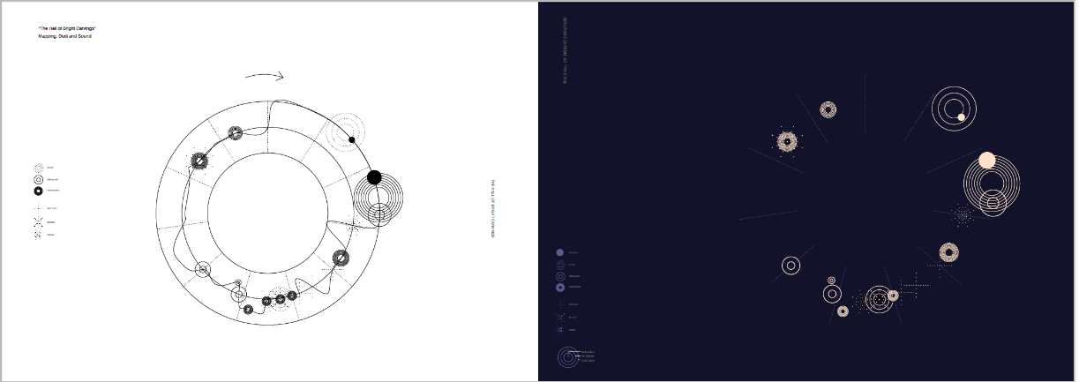

Briener Yu (2019)

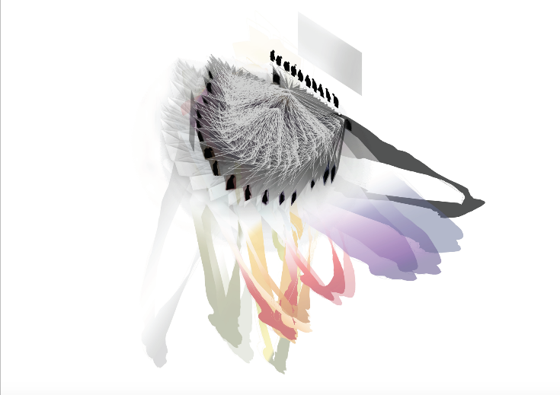

Himali Jajal

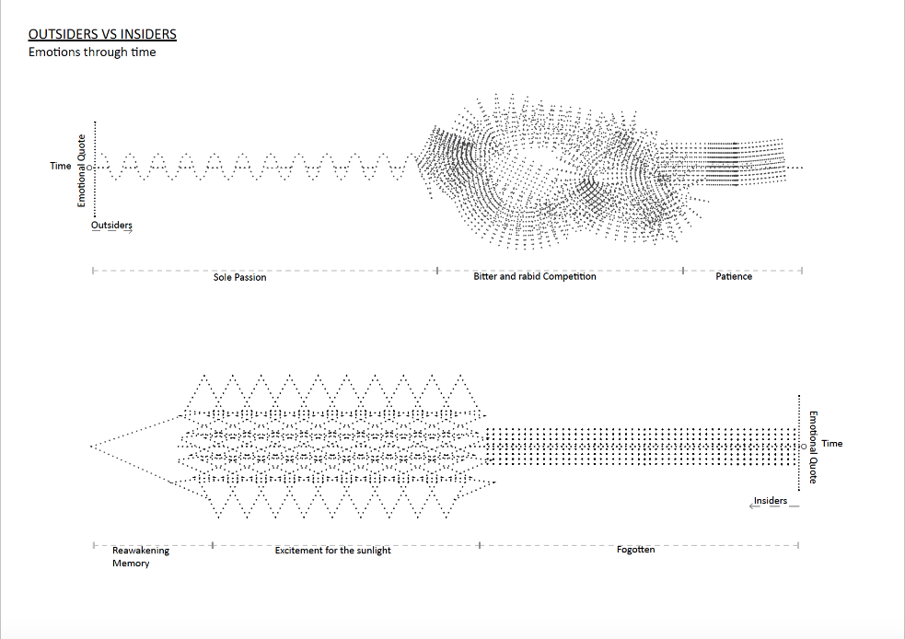

**References as included in the exhibition**

Real/Material/Ethereal 2nd Annual Design Research Conference October 3/4 Monash University

Exhibition Works

Invisible Place Exhibition:

Lee, G. and Miegeville-Little, G. and Students of Invisible Place: Bounded Interiors Design Studio, Bounded Place (video) plus 3 parametric clay models.

Roudavski, S and Ward, W. (2019) Place and Colour (video)

Rutten, J. (2019) Tree as Place (video)

Taylor, M and Studio Sensing Place Students (2019) (video)

Malpas, J. (2019) Sens(ing) of Place